Setting up RealPage Identity on a local machine

The GreenBook system currently consists of 4 separate web sites that will be running under 4 different instances in IIS. Each of these will be running on the local machine under IIS, or they can be run partially using an external system that has yet to be set up, i.e. a shared development environment. The purpose of this document is to train a developer to setup and deploy the Identity Server, API server and Web server on a developer’s machine using Visual Studio and IIS.
Begin by getting latest on the $/RedBook/DEV branch in RedBook TFS. If you map your workspace to a folder under the Users folder, you may experience file permission issues when trying to run the code later under IIS. If you wish to keep the source code under Users\yourusername\something, you will need to add a user, typically Everyone is used, to the folder containing the TFS files, i.e. everything under …\yourusername\something\DEV. Grant the user Full Control and IIS should work correctly.
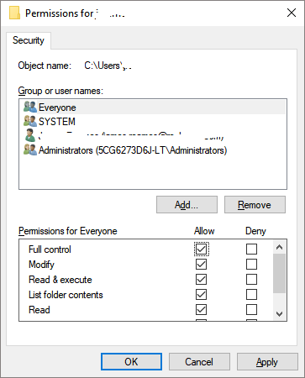

Installing the 5 certificates
- Open the Microsoft Management Console by clicking the windows logo and typing MMC. Add the Certificates snap-in by double clicking on File - Add/Remove Snap-in.
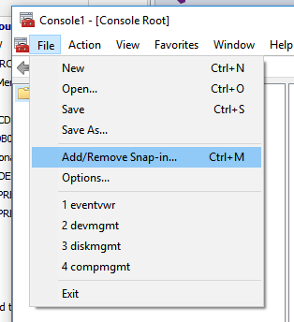
- Double click on Certificates to add it and then select the Computer account.
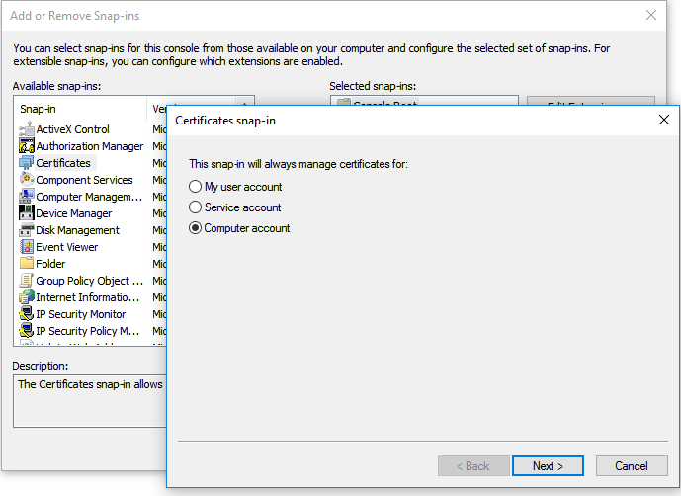
Then click Finish and then Ok to close the Add Snap-in Window
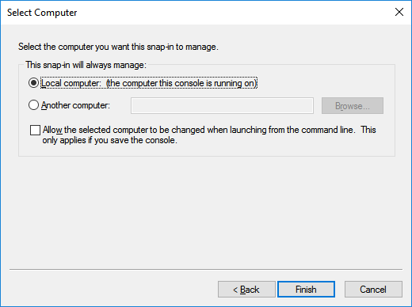
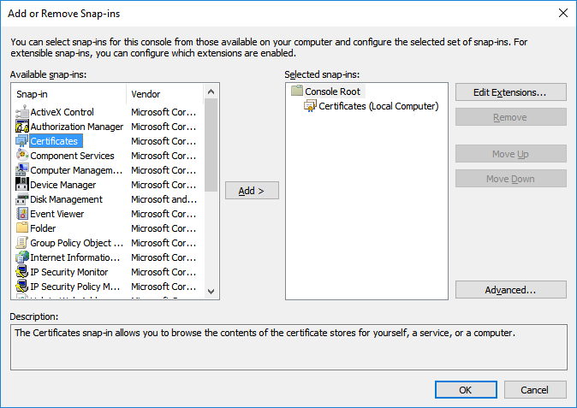
Now open the Certificates (Local Computer) branch and drill down into the Personal – Certificates section.
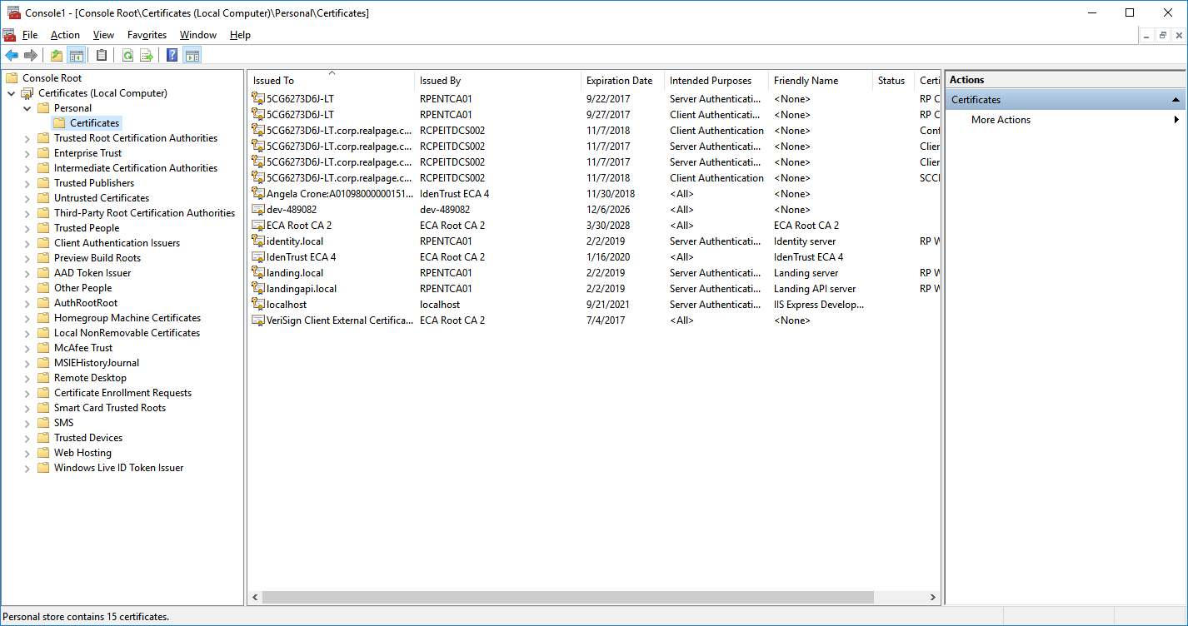

Right click on the Certificates folder and then Import to start importing the certificates.
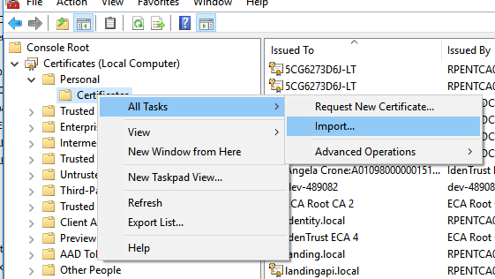

From the certificate Import wizard page, click Browse and navigate to your Workspace Enterprise\Subsystem\ProductLauncher\Extra\certs\local folder. Change the file type to all files.

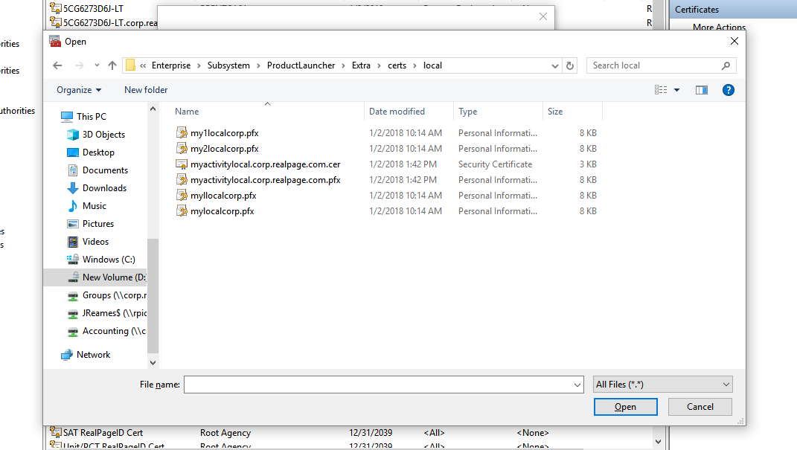
You should see the 4 of the 5 private certificates that need to be loaded. Click on the file, mylocalcorp and Open to begin installing it. Click Next.
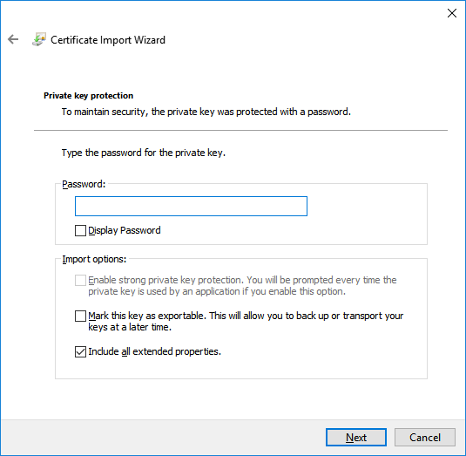
In the import wizard page, type RealPage for the certificate password. Click Next.
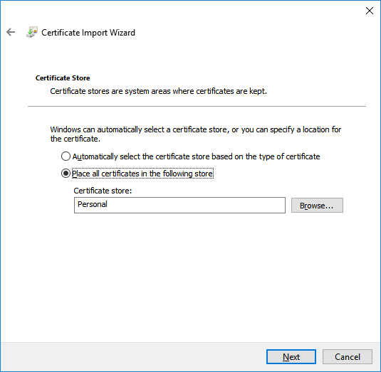
On the final page, click Next to finish installing the certificate.
Repeat the same process for the other 3 certificates, myllocalcorp, my1localcorp and my2localcorp. The final certificate can be found in the folder Enterprise\Subsystem\ProductLauncher\Extra under filename identitysigningcert.pfx. You should now have all 5 SSL certificates loaded in the certificate store. Verify that the certificates installed correctly by double clicking on one and then click on the Certificate Path to verify it is fully trusted. Every level should show correct without errors.
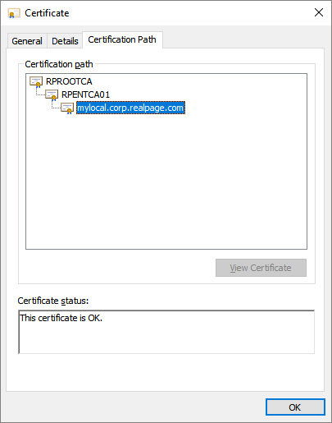
Keep MMC open, it will be needed after the IIS setup is complete.
Setting up IIS locally to run the applications
You need to verify that IIS has all of the necessary components installed before we set up the website. The following features should be enabled to run IIS and the Asp.Net engines correctly to run the projects. Other features may be added in the future but for now, this is the enough to get the systems functioning.
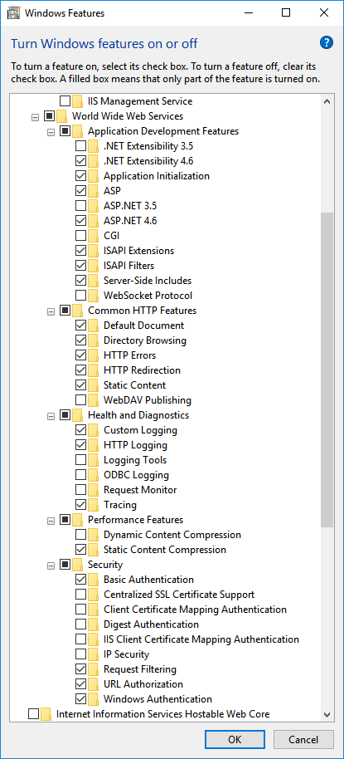

Open the IIS Manager application to begin setting up the 3 websites that will be used. Open the main branch for the machine and then right click on the Sites tab and click Add website.
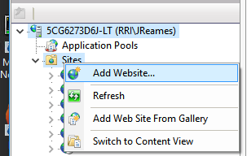

Enter the following settings for the Identity website.
Site name – Identity Server
Physical path - %SystemDrive%\inetpub\wwwroot – this is temporary for now and will get replaced by Visual Studio later
Binding – Type – https
Host name – myllocal.corp.realpage.com
Require server name indication – Checked
SSL Certificate – myllocal.corp.realpage.com.
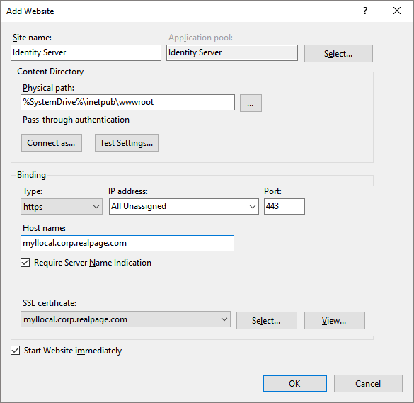

Create another site for the Identity API application.
Site name – Identity API
Physical path - %SystemDrive%\inetpub\wwwroot – this is temporary for now and will get replaced by Visual Studio later
Binding – Type – https
Host name – my1local.corp.realpage.com
Require server name indication – Checked
SSL Certificate – Identity API server
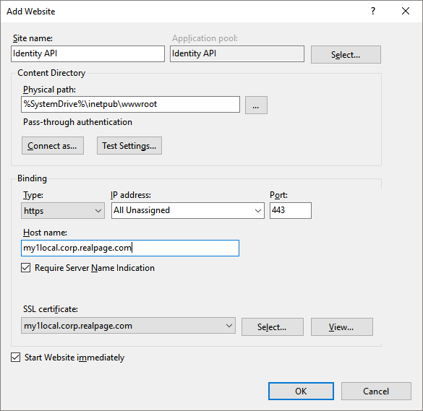

Create another site for the Landing API application.
Site name – Landing API
Physical path - %SystemDrive%\inetpub\wwwroot – this is temporary for now and will get replaced by Visual Studio later
Binding – Type – https
Host name – my2local.corp.realpage.com
Require server name indication – Checked
SSL Certificate – my2local.corp.realpage.com
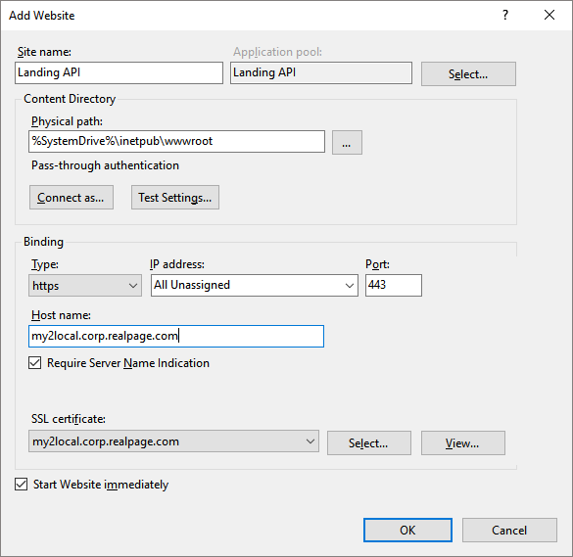
Finally, add the main Landing web site.
Site name – Landing
Physical path - %SystemDrive%\inetpub\wwwroot – this is temporary for now and will get replaced by Visual Studio later
Binding – Type – https
Host name – mylocal.corp.realpage.com
Require server name indication – Checked
SSL Certificate – mylocal.corp.realpage.com
For this site you can also add a binding on port 80 so it will support auto redirecting to https if the mylocal.corp.realpage.com is ever opened using http.
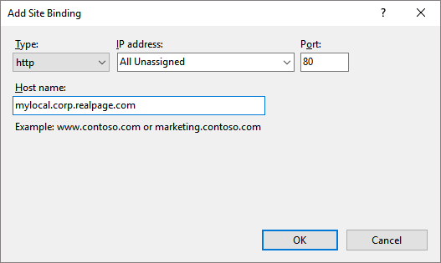

When finished, you should have 4 websites listed for the new applications.
Grant Identity access to the Signing certificate used by Identity Server
Go back to the MMC – Management console and click on the Identity server signing certificate. Right click and click Manage Private Keys.
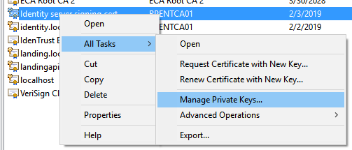
The IIS_IUSRS group needs to be given access to the Identity server signing cert for it to be used successfully. To do this, click Add to add a new user and then change the Locations setting from corp.realpage.com, or whatever it may say, to the machine name. In this example, the machine name is 5CG6273D6J-LT. In the Enter the object name window, type IIS_IUSRS and then click Check Names. The system should find the account and assign it in the enter objects window.
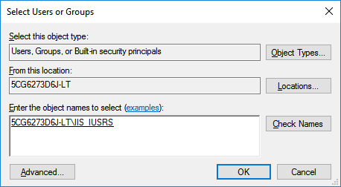
Click Ok to save the user. The IIS_IUSRS account should now be listed in the user group and have Full control.
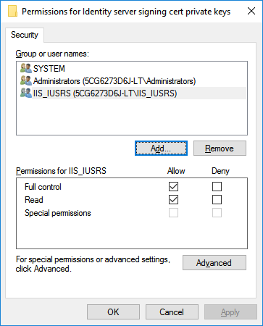
Click Ok to finish this step.

Add the new dns entries to your local hosts file
Open your local hosts file by running Notepad as an administrator and then open the file c:\windows\system32\drivers\etc\hosts
Add the following dns entries for the new websites.
127.0.0.1 mylocal.corp.realpage.com
127.0.0.1 myllocal.corp.realpage.com
127.0.0.1 my1local.corp.realpage.com
127.0.0.1 my2local.corp.realpage.com
Verifying local .user config files
For each of the solutions, open the main solution folder and verify that the solution does not contain a .user file. If one exists, you MUST delete the file for the Visual Studio / IIS binding to function correctly.
Enterprise\Subsystem\ProductLauncher\Web\IdentityServer\Identity\Identity.csproj.user
Enterprise\Subsystem\ProductLauncher\Service\LandingAPI\LandingAPI.csproj.user
Enterprise\Subsystem\ProductLauncher\Web\Landing\Landing.csproj.user

Failing to do this will cause Visual Studio to not map the solutions to IIS correctly and continue to use the ported localhost IIS Express server instead, which we do not want.
Add the URL Rewrite
To install the URL Rewrite feature, you must run the web platform component to download the component. From IIS Manager, click the Get New Web Platform Components link from the right navigation page.
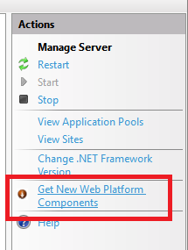
If you haven’t already installed the component, IIS will open up a new webpage and ask you to download the Web platform installer component.
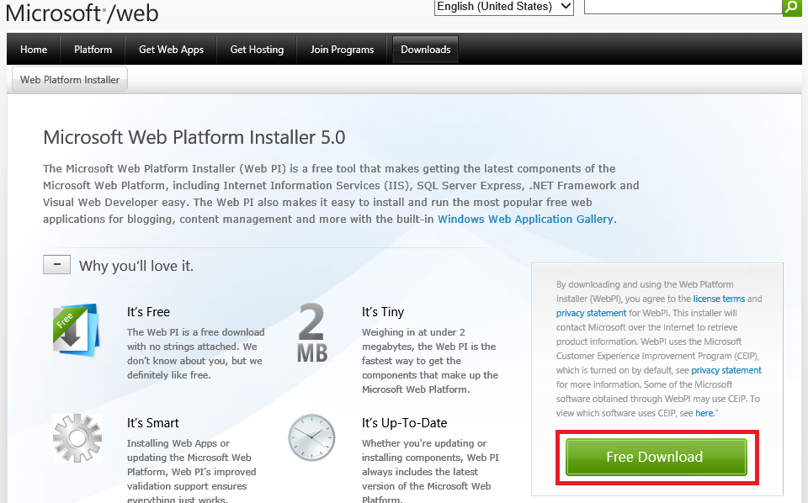

Click the free download button and then run the downloaded setup, the Web platform installer should open,
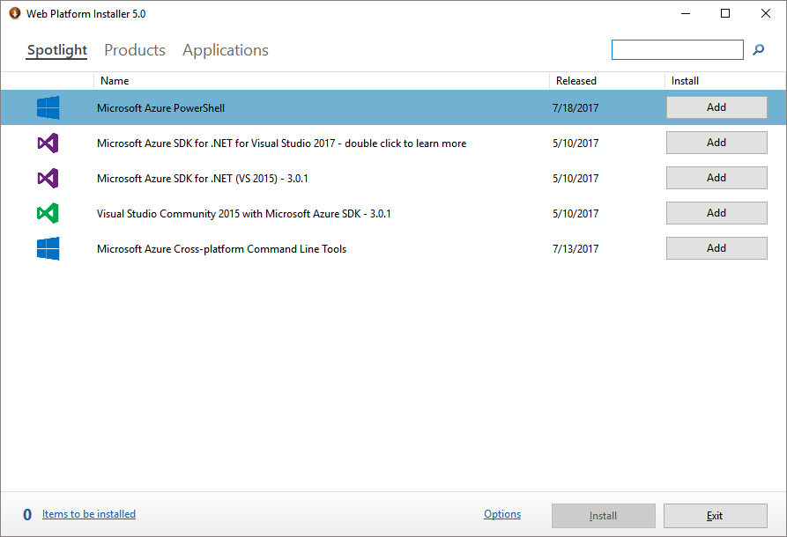
In the search box at the top right corner of the page, type rewrite to search for the URL rewrite component and hit enter.
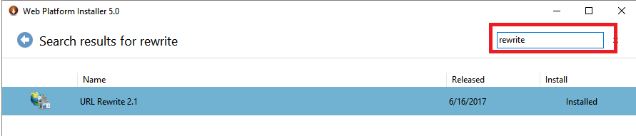
Select it in the list and then click the Install button at the bottom of the page to install the feature. Your IIS should now have the IIS Rewrite feature available when needed.

Opening the solutions in Visual Studio
The solutions can now be opened one by one and debugged to verify they are executing under the IIS web server using the my*local dns entries rather than the locahost:port IIS Express server. Begin by opening the Master solution in the location,
Enterprise\Subsystem\ProductLauncher\MasterProjectSolution.sln
It may prompt you to rebind the IIS virtual folders for each of the 4 websites when first opening, click Ok or Yes to allow the rebinding. You should then be able to build and compile the solution.
If everything is builds correctly, you should be able to open a web browser and open the url https://myllocal.corp.realpage.com. Browsing to this url should start the websites and if it is working correctly the system should redirect the browser to https://mylocal.corp.realpage.com website which will redirect back to the myllocal.corp.realpage.com website login page for the user to authenticate. Enter the james@test.com / P@ssw0rd login and it should then log you into the UnifiedUI web site, which at this step will result in a broken page because the UI code has not yet been compiled.
If you encounter any errors related to the SSL certificate then the IIS user may not have enough access to use the certificate private key. I, James Reames, can assist in testing further to get it working if this occurs.
To verify if the API controllers are working, you can browse to the swagger end point by changing the URL to
https://my2local.corp.realpage.com/swagger
You should get the Swagger web site with the rest methods that are currently available.
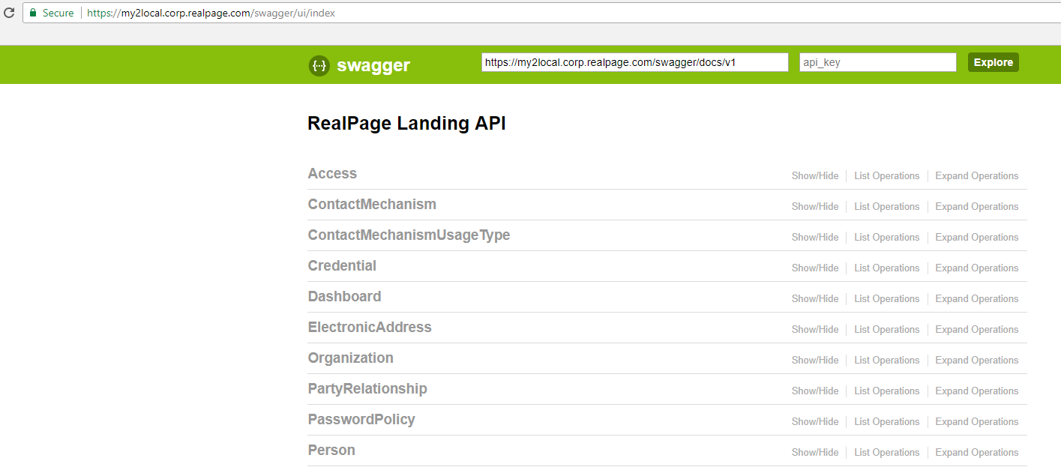

Click on Dashboard to open the methods and then Get on /api/dashboard/getuserproductdetails to open up the method details. Next click on the red exclamation mark on the right side of the page to authenticate with Identity server to see if the API server and Identity server and communicating correctly.
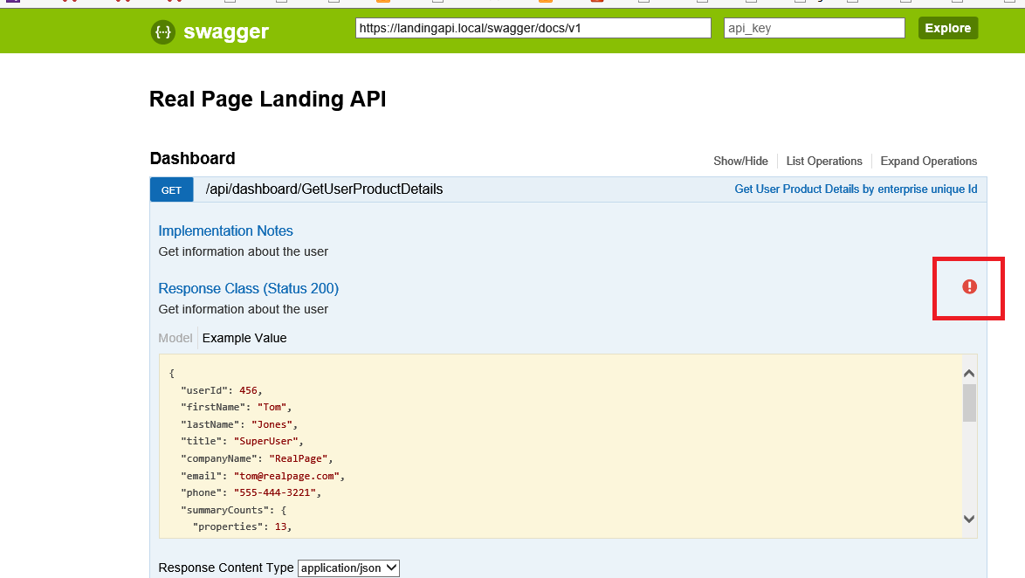
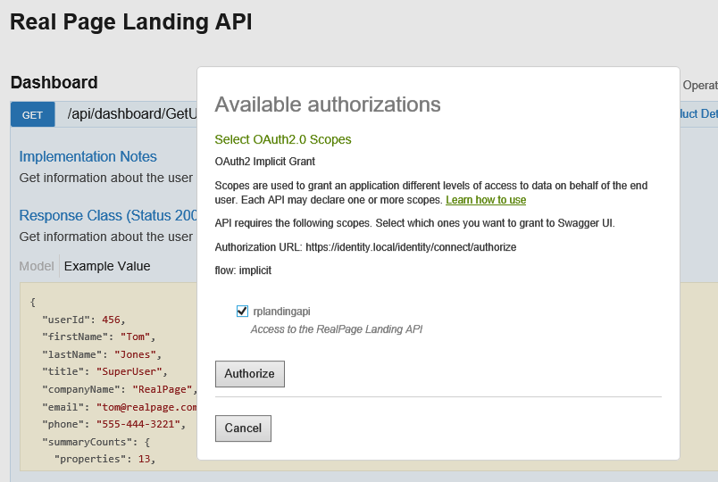
Click Authorize to start the authentication process. It should redirect you to the local myllocal.corp.realpage.com web page and prompt you to log in.
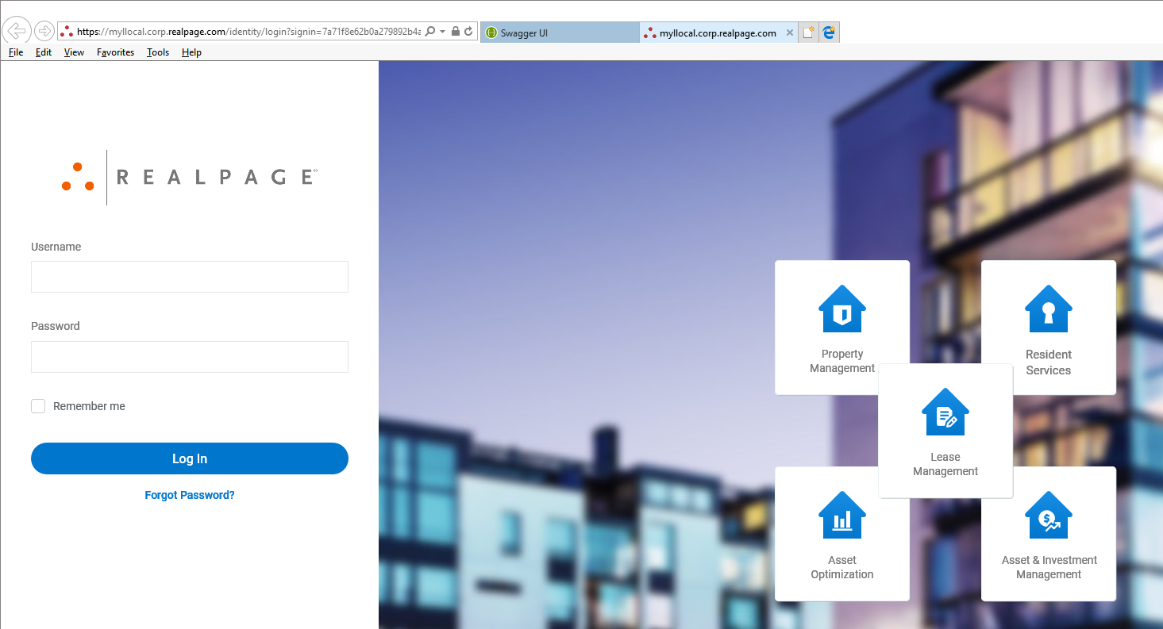
You can use james@test.com / P@ssw0rd credential until you have created your own login. The system should redirect you back to Swagger, but now with a blue exclamation mark, indicating that an authentication token has been retrieved and will be used.
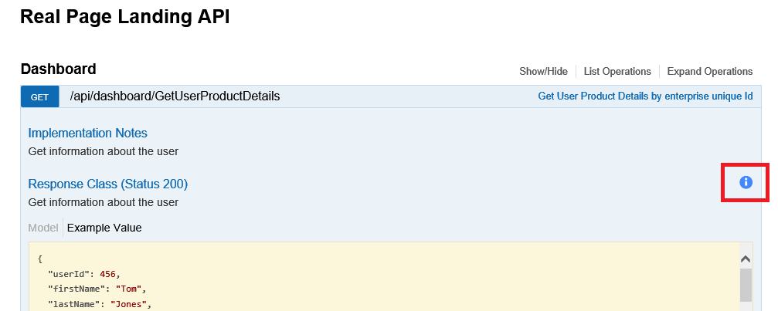
You should now be able to execute the method by entering an enterpriseuserid, 6, and then click the Try it out button. If the token is valid, you should see a valid json result for the call,
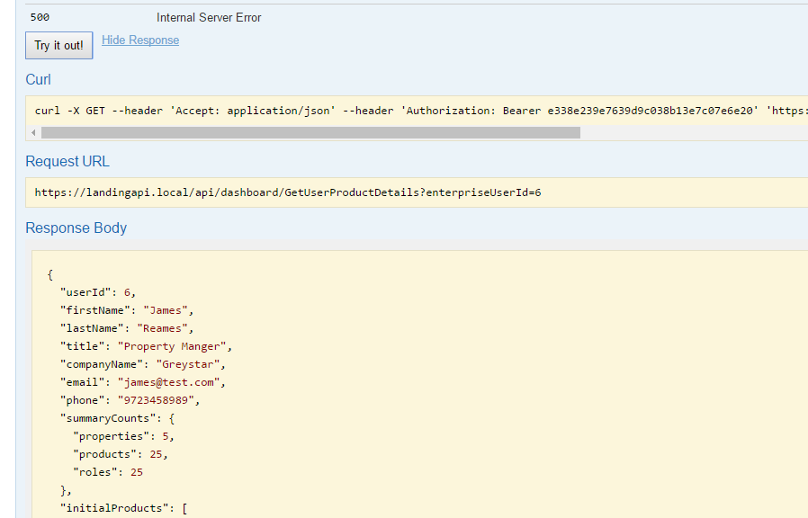

Setting up SPA UI (for developers)
To compile the UI source code, you will need to install the various applications used by the UI team for development. This includes Node.js, Grunt and various other tools.

Prerequisites

- Node.js/NPM – You have to make sure that you have administrator access to your machine because there are times that NPM is unable to modify and create directories due to lack of access.
- Grunt

Setup Node.js
A simple way to check whether Node.js has been installed or not is to open your command prompt and type: npm version. If you see the image below then you are successful; otherwise, proceed. to step 1.
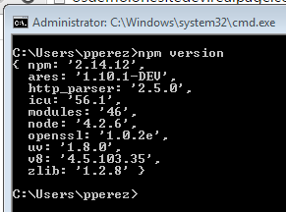
- Go to Node.Js site and download the installer.
- Follow the setup instructions and you’re good to go.

Setup Grunt & Grunt CLI
Just like in Node.js, a simple way to check whether grunt is installed or not is to open your command prompt and type: grunt --version. If you see the image below then you are successful; otherwise proceed to the next step.
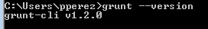
You have to have Node.js setup in order to setup grunt. Go to Grunt’s Getting Started site and it will guide you through the updated installation process.

Compiling UI files
Time to setup UI. Part of NodeJS’s responsibility is to install all modules/plugins that is needed for grunt to work. You are only required to run npm when there are changes in the package.json, such as a new plugin or an update in a version. On the other hand, Grunt is a task runner so grunt runs whichever plugin that it has been configured to run when called. Run Grunt each time there are changes in the UI (HTML, styles, scripts, etc).
Once all these solutions have been compiled and the web.configs are verified to use the correct environments, you should be able to log into the Landing web application by browsing to the URL, https://mylocal.corp.realpage.com, which will redirect you to the local Identity Server at, https:// myllocal.corp.realpage.com , to authenticate your login. Once you have authenticated, it should redirect you back to the https://mylocal.corp.realpage.com and open the application. If the API server is functioning correctly, you will see the logged in user’s name listed in the top portion of the page.

Identity UI
- Go to \Enterprise\Subsystem\ProductLauncher\Web\identity-ui-src
- Open command prompt where Gruntfile.js is located
- Run grunt. You have successfully run grunt when you see, “Done, without errors... All tasks took ## seconds”.
- You should see the latest development in the UI when you visit https://myllocal.corp.realpage.com/


Landing UI
- Go to \Enterprise\Subsystem\ProductLauncher\Web\landing-ui-src
- Open command prompt where Gruntfile.js is located
- Run grunt. You have successfully run grunt when you see, “Done, without errors... All tasks took ## seconds”.
- You should see the latest development in the UI when you visit https://mylocal.corp.realpage.com/
